C-1

Appendix C
Specification Sheets for Common Chips
Pin Outs for Common Chips
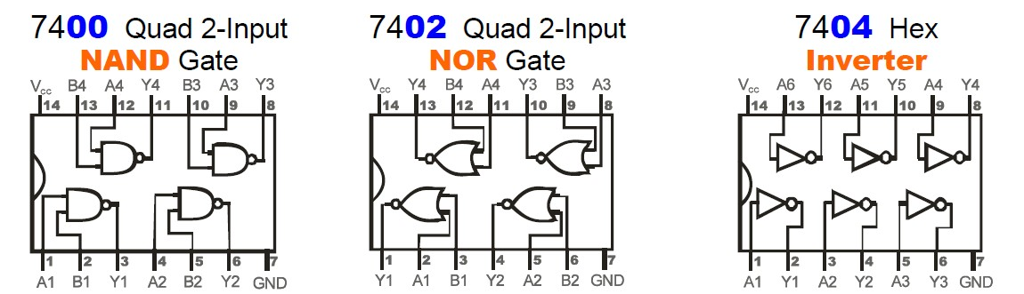

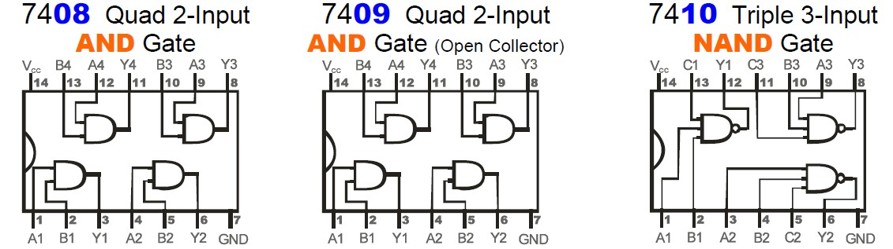

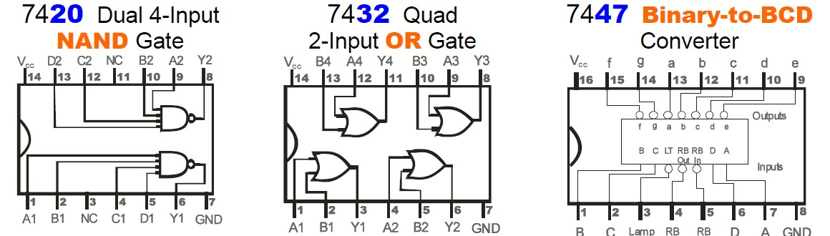

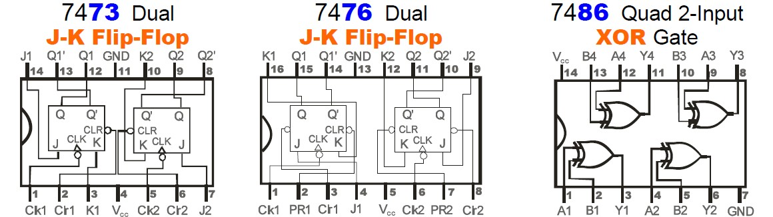

C-2

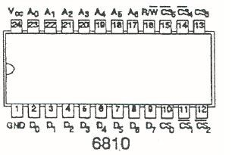

NAND2 7400
NOR2 7402
INV 7404
AND2 7408
NAND3 7410
AND3 7411
NAND4 7420
NOR3 7427
NAND8 7430
OR2 7432
XOR2 7486
JK Dual 7476
4-bit shift register 7495
8 to 1 MUX 74151
2-of-8 inverting decoder 74155

